

EMPLOYEE LEAVE AND PAYROLL MANAGAMENT SYSTEM – Document

Course: Software Engineering
Instructor: Ms. Rabail Zahid

Submission Date: 28th February 2025

BY:
The Scytes
Ruhab Ahmad (23I-0559)
Hasan Altaf (23I-0698)
Muhammad Saqib (23I-0769)

INTRODUCTION
The Employee Leave and Payroll Management System is a Java-based business management application designed to automate employee record handling, leave management, and payroll processing. The system improves organizational efficiency by reducing manual work and ensuring accurate record keeping.

PROJECT VISION
To develop a reliable business system that simplifies HR operations by providing automated employee management, leave processing, and payroll calculation.

INTENDED USERS
Stakeholders
- HR Manager
- Employees
- Organization Management
Stakeholder Needs
- Maintain employee records
- Manage leave requests
- Generate payroll
- Track attendance

FEATURES / FUNCTIONALITY
- Employee registration
- Leave request management
- Leave approval system
- Salary management
- Payroll calculation
- Record viewing
System helps by:
- Reducing paperwork
- Automating calculations
- Improving accuracy

USER STORIES
US-01 - Login to System
As an HR Admin I want to login using valid credentials So that I can securely access the system
US-02 - Add Employee Record
As an HR Admin I want to add a new employee So that employee data is stored in the system
US-03 - View Employee Records
As an HR Admin I want to view employee list So that I can manage employee data
US-04 - Logout from System
As a System User I want to logout securely So that unauthorized access is prevented
Employee Management
US-05 - Update Employee Record
As an HR Admin, I want to update employee information so that records remain accurate.
US-06 - Delete Employee Record
As an HR Admin, I want to remove employee records so that inactive employees are not stored.
Attendance Management
US-07 - Record Employee Attendance
As an HR Admin, I want to mark attendance so that employee presence is tracked.
US-08 - View Attendance History
As an HR Admin, I want to view attendance reports so that I can monitor employee performance.
Leave Management
US-09 - Apply for Leave
As an Employee, I want to submit leave requests so that I can request time off.
US-10 - Approve/Reject Leave
As an HR Admin, I want to approve or reject leave requests so that leave records remain controlled.
US-11 - View Leave History
As an Employee, I want to view my leave status so that I know approval results.
Payroll Management
US-12 - Generate Payroll
As an HR Admin, I want to calculate employee salaries so that payroll is automated.
US-13 - View Payslip
As an Employee, I want to view my payslip so that I know my salary details.
Advance Payment Management
US-14 - Record Salary Advance
As an HR Admin, I want to record advance payments so that deductions can be applied later.
US-15 - Deduct Advance from Salary
As an HR Admin, I want advance payments deducted automatically so that payroll is accurate.
Banking & Transactions
US-16 - Process Bank Transaction
As a Finance Officer, I want to transfer salaries to bank accounts so that employees receive payment.
Reporting & Compliance
US-17 - Generate Tax Report
As a Finance Officer, I want tax reports generated so that compliance requirements are met.
US-18 - View Audit Logs
As an Admin, I want to view system logs so that system activities are traceable.
Access Control
US-19 - Manage User Roles
As an Admin, I want to assign roles so that access is controlled.
US-20 - Manage Permissions
As an Admin, I want to define access rights so that users can only perform authorized actions.

STRUCTURED SPECIFICATIONS
- Login User
Inputs: username, password
Process:
- Validate input
- Check database
- Create session
Output: dashboard / error
- Add Employee
Inputs: name, ID, salary, department
Process:
- Validate fields
- Store in database
Output: success message
- View Employees
Inputs: request from admin
Process: fetch all records
Output: employee list
- Logout
Inputs: logout request
Process: destroy session
Output: login page
- Update Employee Record
Inputs: employee ID, updated details
Process:
- Validate input data
- Locate employee in database
- Update record
Output: update confirmation message
- Delete Employee Record
Inputs: employee ID
Process:
- Verify employee exists
- Remove record from database
Output: deletion confirmation message
- Record Attendance
Inputs: employee ID, date, status
Process:
- Validate employee ID
- Store attendance record
Output: attendance recorded message
- View Attendance History
Inputs: employee ID / date range
Process:
- Retrieve attendance records
- Display filtered results
Output: attendance report
- Apply for Leave
Inputs: employee ID, leave type, dates, reason
Process:
- Validate request details
- Store leave request
- Mark status as pending
Output: leave submission confirmation
- Approve/Reject Leave
Inputs: leave request ID, decision
Process:
- Retrieve leave request
- Update approval status
Output: decision confirmation
- View Leave History
Inputs: employee ID
Process:
- Retrieve leave records
- Display status history
Output: leave history list
- Generate Payroll
Inputs: employee records, attendance, salary data
Process:
- Calculate salary
- Apply deductions
- Store payroll record
Output: payroll generated message
- View Payslip
Inputs: employee ID, pay period
Process:
- Retrieve payroll data
- Display payslip details
Output: payslip
- Record Advance Payment
Inputs: employee ID, amount, date
Process:
- Validate payment details
- Store advance record
Output: advance recorded message
- Deduct Advance from Salary
Inputs: employee ID, payroll period
Process:
- Retrieve advance records
- Deduct from salary
- Update payroll
Output: deduction confirmation
- Process Bank Transaction
Inputs: employee bank details, salary amount
Process:
- Validate account details
- Transfer salary
- Record transaction
Output: transaction confirmation
- Generate Tax Report
Inputs: payroll data, tax rules
Process:
- Calculate tax deductions
- Generate report
Output: tax report
- View Audit Logs
Inputs: system request
Process:
- Retrieve activity logs
- Display chronological records
Output: audit log list
- Manage User Roles
Inputs: user ID, role type
Process:
- Validate role
- Assign role to user
Output: role assignment confirmation
- Manage Permissions
Inputs: role ID, permission settings
Process:
- Update access rights
- Save configuration
Output: permission update confirmation

SCRUM BOARD
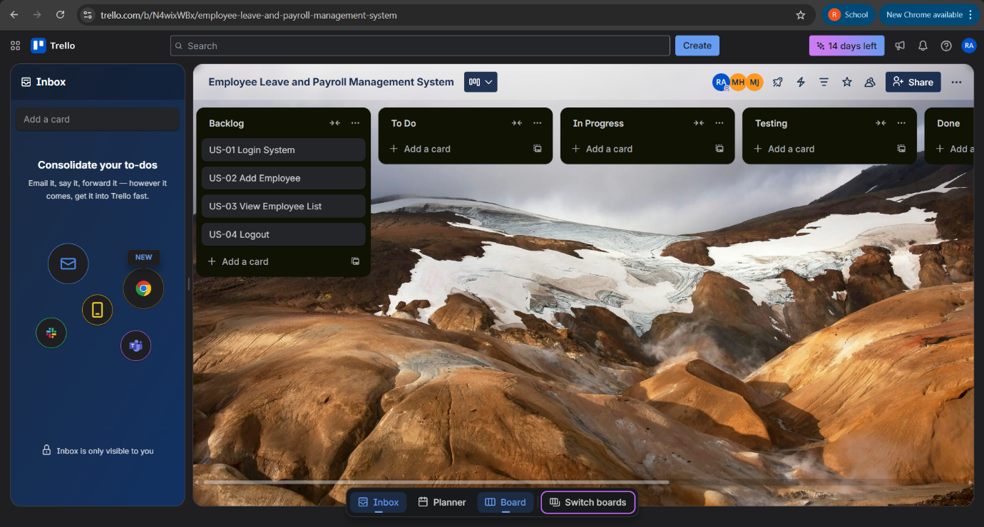

NFR (NON-FUNCTIONAL REQUIREMENTS)
- System must respond within 2 seconds
- Data must be stored securely
- System must be user-friendly
- System must support multiple users
- System must be reliable

ITERATION 1 IMPLEMENTATION SCREENSHOTS

WORK DIVISION
Task | Responsible
Requirements | Ruhab
UI Design | Saqib
Implementation | Ruhab + Saqib
Scrum Management | Hasan
Testing | All members

